# Raspberry pi Architecture

•

Conclusion

The Raspberry Pi is an SBC, or small single-board computer. This credit card-sized computer can be easily connected to a monitor, effectively functioning as a minicomputer when paired with a keyboard, mouse, and display. With its ARM processor and 512MB of RAM, the Raspberry Pi's architecture is thoroughly explored in this article.

**The following diagram shows the architecture of Raspberry Pi:**

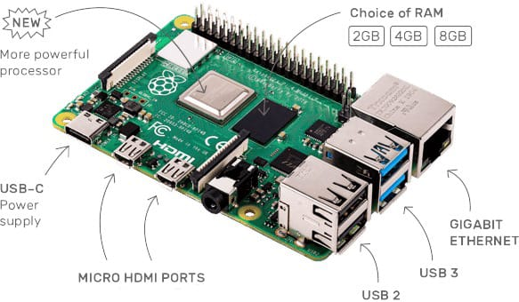

**The following diagram shows some main blocks of Raspberry Pi:**

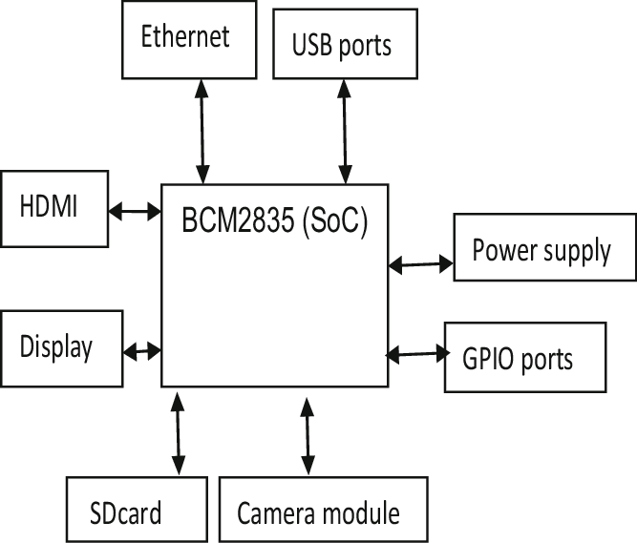

**Raspberry Pi mainly consists of the following blocks:**

* + **Processor:** The Broadcom BCM2835 system on chip, an ARM processor paired with a VideoCore Graphics Processing Unit (GPU), serves as the central component of the Raspberry Pi. This essential element manages the functions of connected devices and performs necessary computations.
  + **HDMI:** The High Definition Multimedia Interface (HDMI) is utilized to transmit video and digital audio data to a computer monitor or digital TV. By utilizing an HDMI port, the Raspberry Pi can effortlessly connect its signals to various digital devices, including monitors, digital TVs, or displays, through the use of an HDMI cable.
  + **GPIO ports:** Raspberry Pi provides General Purpose Input Output ports that enable users to connect and interact with a variety of input devices.
  + **Audio output**: An audio jack is provided for the purpose of connecting audio output devices like headphones and speakers.
  + **USB ports:** A USB port is a widely used interface for connecting different peripherals, including mice, keyboards, and other input/output devices. By utilizing a USB port, the system can easily be expanded by connecting additional peripherals.
  + **SD card:** The Raspberry Pi has a built-in SD card slot, which is essential for booting the device. To start the device, you will need an SD card that has an operating system installed on it.
  + **Ethernet**: The wired network can be accessed through the ethernet connector, which is exclusively available on the Raspberry Pi model B.
  + **Power supply:** A micro USB power port is provided for connecting a 5V power source.
  + **Camera module:** The Pi camera is connected to the Broadcom processor through the Camera Serial Interface (CSI).
  + **Display:** The Display Serial Interface (DSI) serves as a means to connect the LCD to the Raspberry Pi through 15-pin ribbon cables. DSI offers a specialized high-resolution display interface designed specifically for transmitting video data.

# Installation of Raspbian and NOOBS Operating systems Raspbian Installation:

* Obtain the Raspbian image from the official Raspberry Pi website.
* Format the SD card to the FAT32 file system.
* Utilize either Etcher or Win32 Disk Imager to flash the Raspbian image onto the SD card.
* Insert the SD card into the Raspberry Pi.
* Connect the necessary peripherals and power up the Raspberry Pi to initiate the Raspbian setup process.

# NOOBS Installation:

* Obtain the NOOBS zip file from the official Raspberry Pi website.
* Unzip the contents of the NOOBS file into a designated folder.
* Format the SD card to the FAT32 file system.
* Transfer the extracted NOOBS files to the SD card.
* Insert the SD card into the Raspberry Pi device.
* Power on the Raspberry Pi to begin the setup process for NOOBS.

# list of components ( other devices and connector)

Here are the items required to install Raspbian OS on Raspberry Pi:

* SD Card: Stores the operating system and data.
* Power Supply: Supplies power to the Raspberry Pi.
* HDMI Cable: Links the Raspberry Pi to a monitor or TV.
* USB Keyboard and Mouse: Input devices for controlling the Raspberry Pi.
* Ethernet Cable: Connects the Raspberry Pi to a network for internet access.
* GPIO Pins: General Purpose Input/Output pins for connecting sensors, LEDs, etc.
* Camera Module: Attaches to the CSI port to capture images and video.
* Display Connector: Used to connect displays via DPI, DSI, or VGA adapters.
* Audio Jack: Connects speakers or headphones for audio output.
* USB Ports: Used to connect peripherals such as storage devices, Wi-Fi adapters, etc.
* Ribbon Cable: Connects the Raspberry Pi to devices like the Camera Module or GPIO expansion boards.
* Jumper Wires: Utilized for connecting GPIO pins to other components on a breadboard.
* Heat Sink: Aids in dissipating heat from the Raspberry Pi's CPU.
* Fan: Provides active cooling for the Raspberry Pi.
* Cases and Enclosures: Safeguards and houses the Raspberry Pi and its components.

# Difference between BCM and BOARD mode

|  |  |
| --- | --- |
| BVM | BOARD |
| The GPIO pin numbering system is derived from the Broadcom SOC channel. | The GPIO pin numbering system corresponds to the actual pin arrangement on the Raspberry Pi board. |
| Every GPIO pin is designated with a distinct number based on its associated channel on the Broadcom SOC chip. | The GPIO pins on the Raspberry Pi's GPIO header are each assigned a number that corresponds to their physical location. |
| Frequently employed in software development and for programmatically interfacing with GPIO pins. | Beneficial for novices and when utilizing GPIO pins in tangible endeavors. |
| Provides versatility in GPIO pin access, however, necessitates comprehension of Broadcom SOC pin configuration. | Offers a simple method to identify and link GPIO pins without requiring familiarity with the pin layout of Broadcom SOC. |

# 